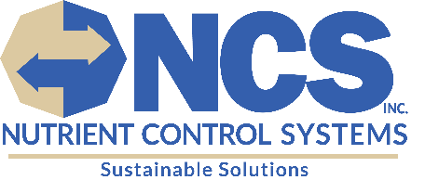
PACKING SLIP
Ship To:
HAUN WELDING SUPPLY INC.
5921 COURT STREET SYRACUSE, NY
Bill To:
Nutrient Control Systems, Inc.
130 Industrial Drive
Chambersburg, PA 17201

Pick Up:
Zeager & Sons
159 Yoder Road
Bainbridge, PA 17502

Date: 09/29/2025 | Purchase Order: 017332 | Sales Contact: Megan Sourbier

Quantity | DESCRIPTION | Class
1 | Pallet: No Bull 7x Absorbent (84 bags)

For any questions or concerns regarding your order, please
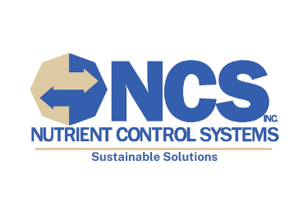
contact Nutrient Control Systems, Inc. at 717-261-5711.

