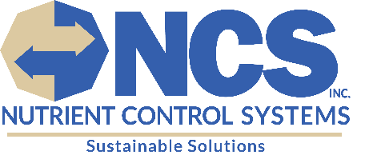
PACKING SLIP
Bill To:
Nutrient Control Systems, Inc.
130 Industrial Drive
Chambersburg, PA 17201

Ship To:
HalenHardy, LLC
305 Main Street ,
Bellwood, PA, 16617

Pick Up:
Zeager & Sons
159 Yoder Road
Bainbridge, PA 17502

Date: 09/09/2025 | Purchase Order: | Sales Contact: Megan Sourbier

Quantity | DESCRIPTION | Class
1 | Pallet: No Bull 7x Absorbent (84 bags)

For any questions or concerns regarding your order, please
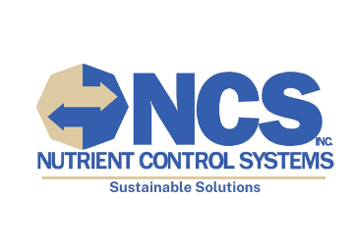
contact Nutrient Control Systems, Inc. at 717-261-5711.

