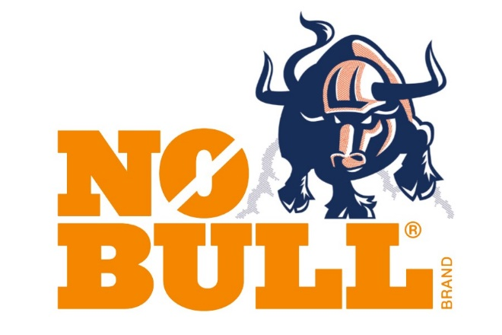
Zeager and Sons Inc.
159 Yoder Road
Bainbridge, PA 17502

Deliver To:
Phillips 66 Lubricants
2300 S. Delmar
Hartford, IL 62048

1 of 2

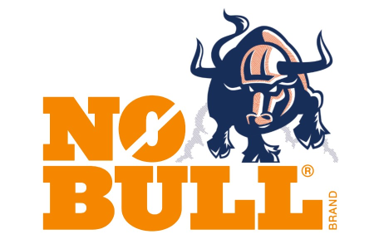
Zeager and Sons Inc.
159 Yoder Road
Bainbridge, PA 17502

Deliver To:
Phillips 66 Lubricants
2300 S. Delmar
Hartford, IL 62048

2 of 2

